***Subscriptions***

Knowledge of Small Business, Personal, and Enterprise subscriptions, desktop applications (Word, PowerPoint, Excel) and services (Teams, Exchange, OneDrive) associated with each subscription type.

*What is Office 365 and how is it used?*

Office 365 is an integrated experience of apps and services, such as Word, Excel, PowerPoint, Teams, OneDrive updated monthly with new features and security.

It is used in Business, Education, and Non-profit to facilitate enterprise activities,

email (Exchange)

document sharing (SharePoint)

Storage (OneDrive)

collaboration (Teams, Yammer).

It is a subscription services, although it can be bought as one-time purchase.

*What are some of the plan comparisons?*

***Business***

Office 365 Business

$8.25 user/month

Apps: Outlook, Word, Excel, PowerPoint, Publisher (PC only), Access (PC only)

Services: OneDrive

Web & Mobile Version of Office Apps

File storage & sharing

Support & Deployment

Office 365 Business Premium

$12.50 user/month

Apps: Outlook, Word, Excel, PowerPoint, Publisher (PC only), Access (PC only) (same as 365 Business

Services: Exchange, OneDrive, SharePoint, Teams

TeamWork Communication

Email & Calendaring

Security compliance

Office 365 Business Essentials

$5.00 User/Month

Apps: No Office Apps

Services: Exchange, OneDrive, SharePoint, Teams

Support and Deployment

Security and Compliance

Email & Calendar

File Storage and Sharing

**For Home**

Office 365 Personal

$70.00/ year (Only One Person)

Apps: Word, Excel, PowerPoint, Outlook, Publisher (PC only) Access (PC only)

Services: OneDrive, Skype

1 TB total storage for 1 person, security sensitive files in OneDrive Vault

MacOS, Android, and Windows obviously

Office 365 Home

$99.99 year (Up to 6 people)

Apps: Word, Excel, PowerPoint, Outlook, Publisher (PC only) Access (PC only)

Services: OneDrive, Skype

1 TB total storage for 1 person, security sensitive files in OneDrive Vault

MacOS, Android, and Windows obviously

Office Home & Student 2019

$149.99 (for one person), (one time purchase)

Apps: Word, Excel, PowerPoint

Services: No services

**Enterprise**

Office 365 ProPlus

$12.00 user/month

Apps: Word, Excel, PowerPoint, Outlook, Publisher (PC only) Access (PC only)

Services: OneDrive

One License covers 5 phones, 5 tablets, and 5 PCs or Macs per user

No Business E-mail

24/7 Phone and Email Support

Fast Track Deployment Support with purchase of 150 seats at no extra cost

Office 365 E1

$8.00 user/month

Apps: No Desktop Apps

Services: Exchange, OneDrive, SharePoint, Teams, Yammer, Stream

Web versions of Outlook, Word, Excel, and PowerPoint, screen 10.1” or less

1 TB storage sharing with OneDrive

Host unlimited HD video conferencing meeting w/ 250 people

Host meetings up to 10,000 people with Teams live events

Advanced Personal analytics with MyAnalytics

Office 365 E3

$20.00 user/month

Apps: Word, Excel, PowerPoint, Outlook, Publisher (PC only) Access (PC only)

Services: Exchange, OneDrive, SharePoint, Teams, Yammer, Stream

One License covers 5 phones, 5 tablets, and 5 PCs or Macs per user

Email hosting with 100 GB mailbox and custom email domain address

Web versions of Outlook, Word, Excel, and PowerPoint

Unlimited Personal Cloud Storage

Host online and video conferencing meeting for up to 250 people

Host meetings for up to 10,000 people with Microsoft Teams

eDiscovery with in-place search, hold, and export?

What is this?

Office 365 E5

Apps: Outlook, Word, Excel, PowerPoint (Access PC only) (Publisher PC only)

Services: Exchange, OneDrive, SharePoint, Teams, Yammer, Power BI, Stream

Advanced Personal and organizational analytics with MyAnalytics and Power BI Pro

Adding and Removing Users

Users, in the navigation pane to the left

1) Active Users, 2) Add User, 3) Fill in Text Boxes, and PW settings then select next

4) Select Licenses to assign to user (very important) 5) In optional settings, select whether the user has no admin center access or has Admin Center Access from the radial buttons.

5) This is when you select the role you want your user to have

Editing user roles who are already members

1) Click Active Users in the left-hand navigation pane. 2) Click the User whose Username, group, role, or contact information you want to manage and click the respected element.

1) This page is also where you manage Accounts, Devices, Licenses and Apps, Mail, and OneDrive. From the tabs on the particular User

Email Aliases

1) I’m not sure why in the videos there is an email alias section and not one the actual admin center. Regardless, I believe it can be done simply enough by changing the Username

Add and remove users, assign licenses to users, assign users to administrative roles, change users display name and add email aliases, reset PWs, assign self-service PW resets to users, add and remove cards for task performed frequently.

*How do you reset a user PW?*

When a user forgets their PW you’ll get a PW reset request in e-mail.

From admin center

1) Users 2) Active Users 3) Key icon 4) click auto generate a new pw, or set user pw. 4) The Admin user e-mail is already added, if you have a personal email you can add that. 5) select the button send e-mail and close, the user receives a email with the PW reset instructions.

*How do you allow users to reset their own PW? Self service PW request.*

To allow users to reset their own pw each time you can set-up Self-Service PW request. From admin center

1) Select settings 2) Security and Privacy 3) Azure AD Admin center 4) Users 5) Password Reset 5) Select All (other options are selected and none) 6) Save 7) The next time a user logins into an account, they’re asked for additional information. 8) They’re asked to authenticate with the phone email or both. 9) Users can now reset their own password when needed.

View and print bills, update payment methods, filter based on invoice

*View and Print Bills*

From the admin center in the navigation pane, click Billing

Then Bills and Payments

If you don’t see an invoice, filter by the last six months

To see complete details, you must download the PDF

*How do you update the payment method?*

1) Billing 2) Payment methods 3)To edit an existing card, choose three dots besides card

*Review Usage Reports filter based on anonymous identifier information*

In The admin center office, click reports, usage reports allow you to see how employees are using the different services of your office 365 subscription.

We can see all of the different reports available by clicking reports, usage.

We can see details of the reports by clicking the cards.

Active User reports shows which reports are used most often by people in your business. You can view information specific to an individual (default settings do not show identifiable information)

Click Settings, Services & add-ins, from the reports panel you can turn anonymous identifier on

You now can see identifiable information, specific to an individual

*Create a companywide signature*

Appears on every email sent by people in your organization. Displays company contact information or legal disclaimer.

From Microsoft 365 Admin center

Select exchange, select mailflow, (add a rule, Plus sign), apply a new rule is very similar to the apply disclaimers in the drop down text box. The apply disclaimer drop-down has an enter text and select one link.

Enter a name for the rule, apply rule as required, on the do the following dropdown, verify the append the disclaimer is displayed, select enter text, then enter the text for your email signature. You can format text with HTML, if you want an image everyone can see you’ll need an image from a publicly available URL to that image. Copy image address into HTML. Select Okay,

To make sure Signature works with encrypted email, add a fallback option.

Select okay, select wrap, then okay.

Scroll down and leave the mode set to enforced.

Select save, then select yes. To apply the rule to all future messages.

(Not sure of about the logic to the fallback option, will need further explanation

*Add a new Domain*

A company might have multiple domain names that it uses for different purposes. EX: Contoso.com, & Contoso.net.

If you want to use a different spelling of contosoco.com, contosocos.com

In the admin center, select setup, get your custom domain setup select view, select manage, the select add domain, select domain, then select next (This is deprecated and has since changed since the video’s were produced)

In the Admin center click Set-up, Domain, Add Domain

In order to receive email with this new domain, you’ll need to add it as a new email alias for each user.

Select Users, Active Users, then the email alias you want to add the email for.

Choose manage email alias, select add email alias, save changes, repeat these steps for everyone who needs an email with new domain.

**Exchange Admin**

Navigate the Exchange admin center in the features pane and use the tabs and toolbar to administer different features (permissions, mail flow, compliance management).

*Admin center*

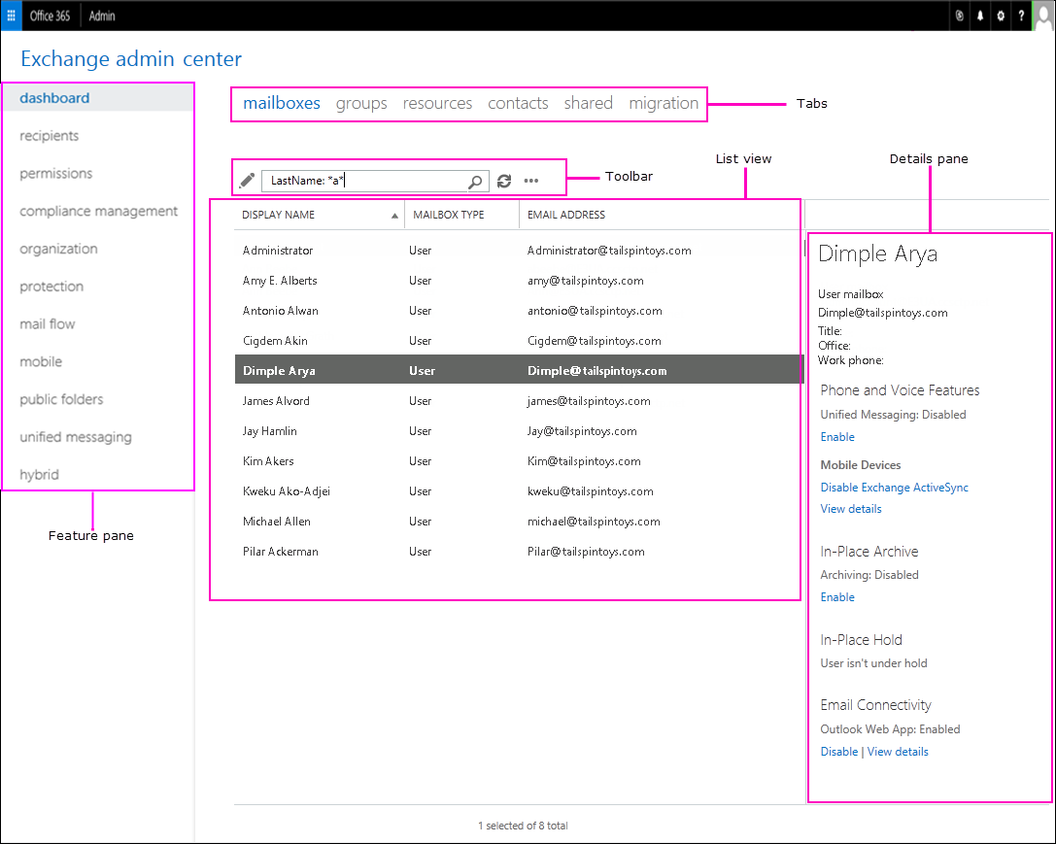

*Feature Pane*

Dashboard -overview of admin center

Recipients – view and manage mailboxes, groups, resource mailboxes, contacts, shared mailboxes and mailbox migrations

Permissions – Manage administrator roles, user roles, and Outlook on the web

Compliance management – Manage In-Place eDiscovery & Hold? (what is this), auditing, DLP, retention policies, retention tags, and journal rules

Organization – Manage organization sharing and apps for Outlook

Protection – Manage malware filters, connection filters, content filters, outbound spam and quarantine for organization

Mail Flow – Manage rules, message tracing, accepted domains, remote domains, and connectors.

Mobile – Manage the mobile devices that you allow to connect to your organization. You can manage mobile device access and mobile device mailbox policies

Public folders – Manage public folders and public folder mailboxes

*Tabs*

Are your second level of navigation. Each of the feature areas contains various tab

*Toolbar*

Some tabs have a toolbar, the toolbar has icons that perform a specific action.

Common Icons

Plus sign, Add, new

Pencil, edit

Trash Can, Delete

Magnifying glass, search

*List View*

When you select a tab, in most cases you’ll see a list view.

In Exchange Online, the viewable limit from within the Exchange admin center list view is approximately 10,000 objects

*Details Pane*

When you select an item from the list view, information about that object is displayed in the details pain.

Set predefined permissions based on RBAC, assign roles (such as: discovery management, help desk, organizational management) for administrators and specialized users

***Exchange Permissions***

Exchange Online in Office 365 includes a large set of predefined permissions, based on the Role Based Access Control (RBAC) permission model which you can use right away to easily grant permission to your administrators and users.

You can use the permission feature in Exchange Online so that you can get your new organization up and running quickly.

RBAC is also the permissions model that’s used in Microsoft Exchange Server.

*Role-based permissions*

In Exchange Online, the permission that you grant to administrators and users are based on management roles. A management role defines the set of tasks that an administrator or user can perform.

EX: Mail Recipients, defines the task that someone can perform on a set of mailboxes, contacts and distribution groups.

When a management role is assigned to an administrator or user that person is granted the permissions provided by the management role. There are two types of management roles

Administrative roles: These roles contain permissions that can be assigned to administrators or specialist users using role groups that manage a part of the Exchange Online organization such as recipients or compliance management.

End-User roles: These roles, which are assigned using role assignment policies, enable users to manage aspects of their own mailbox and distribution groups that they own. End-User roles begin with the prefix My.

Management roles give permissions to perform tasks to administrators and users by making cmdlets available to those who are assigned the roles. BC Exchange admin center (EAC) and Exchange Online PS use cmdlets to manage Exchange Online, granting access to a cmdlet gives the administrator or user permission to perform the task in each of the Exchange Online management interfaces.

Assign end user roles, use role assignment policy to allow users to customize their mailbox or distribution groups they own with given permissions. Implement default role assignment policies for mailboxes.

Exchange Online provides role assignment policies so that you can control what settings your users can configure on their own mailboxes and on distribution groups they own. These settings include: display name, contact info, voice mail settings, and distribution group membership.

Role assignment policies are added directly to mailboxes and each mailbox can only be associated with one role assignment policy at a time.

Of the role assignment policies in your organization, one is marked as default. Default role assignment policy is associated with new mailboxes that aren’t explicitly assigned a specific role assignment policy when they’re created.

Permissions are added to role assignment policies using end-user roles. End-user roles begin with My and grant permissions for users to manage only their mailbox or distribution

groups they own. They *can’t* be used to manage any other mailbox, only end-user roles can assign to role assignment policies.

When an end-user role is assigned to a role assignment policy, all of the mailboxes associated receive the permissions granted by the role.

*Office 365 permissions in Exchange Online*

Office 365 roles and Corresponding Exchange roles

Office 365: Global Administrator Exchange Online: Organization Management

Office 365: Password Admin Exchange Online: Password Administrator

When you add a user to either the Global administrator or PW administrator Office 365 roles, the user is granted the rights provided by the respective Exchange Online role group.

Users can be granted administrative rights in Exchange Online w/o adding them to Office 365 roles. This is done by adding the user as a member of an exchange Online role group, when added directly to Exchange Online role group, they’ll receive the permissions granted by that role group in Exchange online.

Users can be added to any of the role groups listed in the “Built-in role groups table” in role groups with the exception of the Company Administrator and Help Desk Administrators role group.

*Work with role groups*

To manage your permissions using role groups in Exchange Online, we recommend that you use the EAC. The EAC provides simple dialog boxes, such as the new role group dialog box to perform these task.

Exchange Online includes several role groups that separate permissions into specific administrative areas.

If these existing role groups provide the permissions your administrators need to manage your Exchange Online organization, you only add your administrators as members of the appropriate role groups.

After you add administrators to a role group, they can administer the feature that relate to that role group.

**Important**

If an administrator is a member of more than one role group, Exchange Online grants the administrator all of the permissions provided by the role groups he or she is member of.

If none of the role groups included with Exchange Online have the permission you need, you can use the EAC to create a role group and add the roles that have the permissions you need.

If there’s an existing role group that has some, but not all, of the permissions you need, you can copy it and make changes to create a role group, without affecting the original role group. By adding and removing roles to and from role groups, you turn on and off administrative features for members of that role group.

*Work with role assignment Policies*

To manage the permissions that you grant end users to manage their own mailbox in Exchange Online, use EAC.

SharePoint

Learning how Enterprises use SharePoint to share and manage content, knowledge, and applications to; empower teamwork, quickly find information, and seamlessly collaboration across the organization.

SharePoint Online is a cloud-based service that helps organizations share and manage content, knowledge and applications to:

• Empower teamwork

• Quickly find information

• Seamlessly collaborate across the organization

Before you dive into building and configuring your organization’s SharePoint environment, there are a few things you should think about. For example, how will you manage sites with the objective to collaborate (team sites) broadcast and share content for viewing (communication sites)

Knowledge of the difference between hierarchical sites and flexible hub sites and how they form the connective tissue of an intranet.

*The process of setting up SharePoint is divided into three steps*

1) Set up your SharePoint environment Who does this? Global admins and SharePoint admins in Office 365

Plan your SharePoint hub sites

Collaborate with guest

Train your users

Manage Site Creation

*Plan your SharePoint hub sites*

Hub sites help your organize your intranet.

*Setting the stage*

Provide an important building block for your intranet, are the “connective tissue” you use when organizing families of team’s sites and communication sites together.

One of the key principles of modern intranets based on SharePoint is that each unit of work should get a separate site collection to optimally manage governance and growth over time. Each communication site and Office 365 group-connected team sites is created as a site collection that can have its own permissions.

A hub site (most commonly created from a communication site) should also be considered its own unit of work that brings together numerous other sites.

Seems like site collection, communication site and hub sites are all pretty similar

In the past many organizations used subsites to create connective tissue for their intranets, using the site collection’s shared navigation to connect sites and the hierarchical structure of subsite relationships to nest sites within sites.

However, subsites are a physical construct reflected in the URL for content, if you reorganize your business relationships, you will break all the intranet relationships in your content.

Subsites also create challenges related to governance, because many features in SharePoint apply to all sites within the site collection, whether you want them to or not.

What always happens in Business? Change!

This is a key benefit of SharePoint hub sites; the model relationships as links rather than hierarchy or ownership, so that you can adapt to the changes in the way you work in a dynamic changing world.

Understanding the difference between Teams sites (collaboration), Communication sites (broadcast) and Hub sites (connection).

Office 365 provides three main building blocks to help you create your intranet in a way that allows you to configure experiences that align with your business, your employees, and your readiness.

Team Sites (collaboration)

Communication Sites (Communication)

Hub Sites (Connection)

**Teams**

Learning how to plan a rollout of teams and contingencies to consider beforehand when rolling out in a public setting, or without any other Office 365 services present.

If your coming to Teams from Skype for business (online or on premise) or if you need a hybrid configuration, you still want to follow the recommended path above for rolling out Teams, but it requires extra planning. You’ll first to configure hybrid connectivity between your on-premise environment and Microsoft 365. The easiest option is to simply upgrade to Teams.

<https://docs.microsoft.com/en-us/skypeforbusiness/hybrid/plan-hybrid-connectivity>

*Get started driving adoption of Microsoft Teams*

Adoption prerequisites

Before getting started, make sure that

Teams is installed and licenses are assigned in your environment. Licenses should be assigned to core team and early adopters who will participate in this initial project phase.

Download desktop and mobile apps

Office 365 adoption framework

Adoption phases (for teams) (This is for Enterprises)

Start: Gather your team together, set up your initial team, and use Teams to begin planning team’s adoption.

Experiment: Controlled Growth bring early adopters; which business units benefit from collaboration.

Scale: Turn on Teams capabilities for all your employee

<https://docs.microsoft.com/en-us/microsoftteams/teams-adoption-get-started>

*Get started* (This is a different tree than the adoption perquisites) (This is for small business)

Recommend you create two or three teams and channels for a select group of early adopters. Teams lets you quickly pull together a team with people inside and outside your organization, chat with others to drive fast and inclusive conversations, securely share and coauthor documents and iterate on project The steps to roll out first set of teams

1: Create your first teams and channels

2: Onboard early adopters

3: Monitor usage and feedback

4: Get resources to plan your organization-wide rollout

<https://docs.microsoft.com/en-us/microsoftteams/get-started-with-teams-quick-start>

Configuring channels within teams to keep conversations organized by topic, project, or discipline.

1) Create your first teams and channels

A team is a collection of people who gather together around a common goal. Channels are collaboration spaces within a team where the actual work gets done.

“Get to know Teams” team

Your project team can use the “getting to know Teams” team to ensure they’re set up with Teams clients, have some initial conversations, and explore what Teams can do.

Jump to (Overview of teams and channels in Microsoft Teams)

How Teams allow individual teams to self-organize and collaborate across business scenarios

**Teams** are a collection of people, content, and tools surrounding different projects and outcomes within an organization

* Can be created to be private to only invited users
* Teams can also be created to be public and open and anyone within the organization can join. (up to 5000 members)

Is designed to bring together a group of who work closely to get things done.

**Channels** Are dedicated sections within a team to keep conversations organized by specific topics, project, disciplines—whatever works

* Are places where conversations happen and where work actually get done. Can be open to all team members or can be private.

These are examples of channels you would configure for a brand new teams rollout for early adoptes

| **Channel** | **Description and usage** | **Pinned tabs, bots, and apps** |
| --- | --- | --- |
| General | All teams start with a General channel. Use this channel to make announcements as you start getting to know Teams. |  |
| Say hi | Introduce yourself to the team and share what you want to get from Teams. |  |
| How do I | A channel to ask how-to questions. Step 1 – install the desktop and mobile clients. Step 2 – jump into Teams. | Pinned tab that links to the [Teams help center](https://support.office.com/teams) Pinned tab that links to [Teams training videos](https://support.office.com/article/microsoft-teams-video-training-4f108e54-240b-4351-8084-b1089f0d21d7) Pinned tab that links to [Teams desktop and mobile client download links](https://teams.microsoft.com/downloads) |
| Feedback | Share your thoughts on your Teams experiences. | Pinned tab with Polly Poll |
| Ideas for future teams | Share your thoughts on where Teams can drive additional value in your organization. What could these teams be called? Who would be members? |  |
| Support | If something isn't working as expected, use this channel to get help. |  |

Create a team

On the left side of Teams, click Teams, at the bottom of the teams list, click Join or create a team, and then click Create a new team.

Once you've created the team, invite people to join it. You can add individual users, groups, and even entire contact groups (formerly known as "distribution lists").

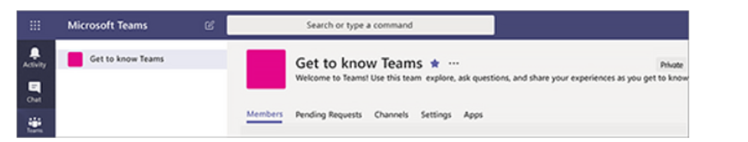

Add a team owner

Find the team that you created, click More options ˙˙˙ > Manage team. Then go to the Members tab. Find the people you want to designate as team owners. Under Role, click Owner.

Create a channel in a team

Find the team that you created, click More options ... > Add channel. You can also click Manage team and add a channel in the Channels tab.

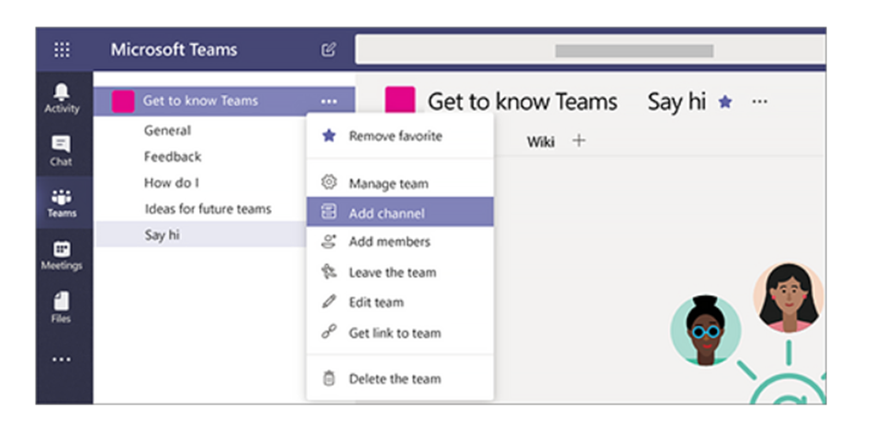

Knowledge of user role in Teams (Team owner and member and grasp of permissions assigned to each) and moderator capabilities for a channel.

Within Microsoft Teams there are two user roles: **owner** and **member**. By default, a user who creates a new team is granted the owner status. In addition, owners and members can have moderator capabilities for a channel (provided that moderation has been set up). If a team is created from an existing Office 365 Group, permissions are inherited.

The table below shows the difference in permissions between an owner and a member.

|  | **Team Owner** | **Team Member** |
| --- | --- | --- |
| **Create team** | Yes1 | No |
| **Leave team** | Yes | Yes |
| **Edit team name/description** | Yes | No |
| **Delete team** | Yes | No |
| **Add standard channel** | Yes | Yes2 |
| **Edit standard channel name/description** | Yes | Yes2 |
| **Delete standard channel** | Yes | Yes2 |
| \***Add private channel** | Yes | Yes2 |
| \***Edit private channel name/description** | No | N/A |
| \***Delete private channel** | Yes | No |
| **Add members** | Yes3 | No4 |
| **Request to add members** | N/A | Yes5 |
| **Add tabs** | Yes | Yes2 |
| **Add connectors** | Yes | Yes2 |
| **Add bots** | Yes | Yes2 |

Moderator Capabilities

In addition to other capabilities, team owners and members can have moderator capabilities for a channel (provided that moderation is turned on for a team).

Moderators can start new posts in a channel and control whether team members can reply to existing channel messages. (THINGS MODERATORS CAN DO)

Moderator capabilities are assigned at the channel level. Team owners have moderator capabilities by default. Team members have moderator capabilities turned off by default

Viewing Teams usage report, Teams user activity report, and Teams device usage report to manage Teams service in Admin center or Microsoft Teams Admin center

Teams reports in the Microsoft admin center give you insights into how Teams is used in your organization. Use these reports to get a view into Teams Usage, user activity and device usage across your organization.

Team usage reports: This reports gives you an overview of usage activity in Teams, including the total active users and channels, and the number of active users and channels, guests, and messages in each team.

Teams user activity report: This report gives you insight into the types of activities users engage in, such as how many people communicate through 1:1 calls, channel messages, and private chat messages.

Teams device usage report: This report shows you how users connect to Teams, including how many people use Teams on their mobile devices when on-the-go.

▪ Learning about five types of groups that are used to manage access to resources and for communication. (Office 365 groups, Security, Mail-enabled, Distribution, Share mailbox) and how group membership is based on Azure Active Directory Accounts.

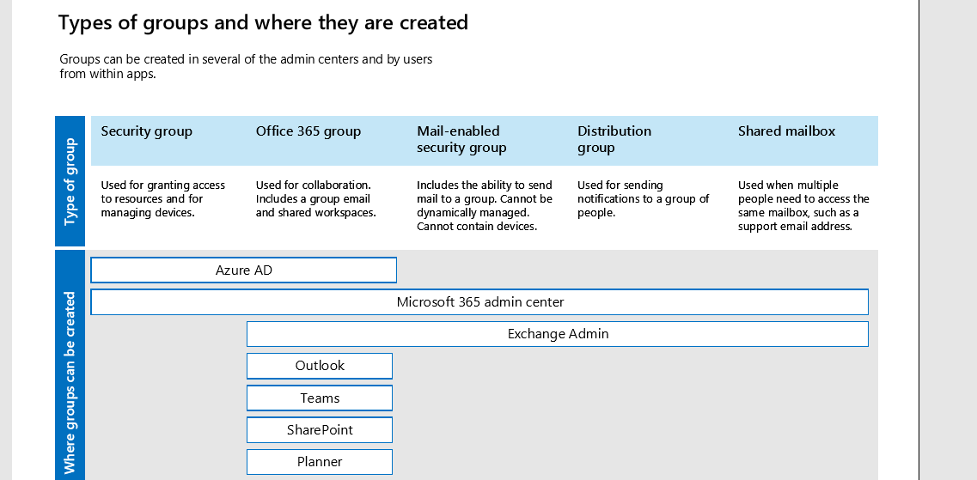

New Freelancer model (no longer vendor)

325-300

Work from home, a compter

8gb or better

10mbps up and download

Monitor metrics and KPIs

Agents frontline support calls,

Specialized front

SMEAD (Subject Matter Experts)

Work with agents directly

Upwork

27th on Janurary 10 day training course

Average length of ticket

Multiple tickets, Internal and External tools,

6 Shifts,

Change in thought process,

Contracts

Three month contracts, Upwork, Connie will contact, negotiated wage

Background check, Tax W-2, (Get a w2), renewed every 3 months,